Table of Contents
What Is This Resource Kit? 2
What is the aim of this resource kit? 2
What is included in this resource kit? 2
How To Run Cell and Gene Therapy Discussion Groups with Your Donors 4
What is a discussion group? 4
A discussion group is an established methodology for exploratory research. 4
This kit provides ‘stories’ that your discussion group can talk about together. 4
How many participants and discussion groups would be ideal? 4
Consider recruiting around 20 participants. 5
Aim for no more than five participants per discussion group. Three or four is a good number. 5
Who should I invite to participate? 5
Recruit a sample that is demographically representative of your register. 5
Include in your sample registered donors who have and who have not donated. 5
Keep a record of important demographics of your participants. 5
How you will recruit participants depends on your local context. 6
What practicalities should I consider for the discussion group? 6
A discussion group last around 1.5 hours, but may be slightly longer or shorter. 6
Face-to-face discussion groups should ensure everybody is comfortable and able to see one another. 6
Online discussion groups should use the most appropriate and accessible platform. 7
What does facilitating a discussion group require of me? 7
The Discussion Group Schedule provides ideas on structuring your discussion group. 7
You should aim to facilitate a relaxed, conversational environment where participants do most of the talking. 7
Try to limit your speaking to open questions, and to requests for people to contribute or expand their points. 8
Are there financial costs to this work? 8
There will be costs (monetary or time) for transcribing your discussion groups. 8
There may be costs associated with translating stories and questions. 8
Analysing Data from Discussion Groups 10
Develop a written script or transcription of your data. 10
Consider working with another person for the analysis process. 10
Analyse your data for themes using a systematic method. 10
Use a tool like Microsoft Excel to help collate and organise your themes. 10
Summarise your findings into a report. 12
Informed Consent and Local Ethical Review 13
Consider what kinds of local approval you will need before undertaking the research. 13
Seek informed consent from your discussion group participants. 13

What Is This Resource Kit?

This resource kit is a collection of advice and materials on how to run discussion groups with donors from your registries. It has been designed to explore the broad theme of cell and gene therapy (including working with external organisations, sourcing starting material from donors, cryopreservation, etc.), and touches on a range of key topics that are of interest to us as a wider community.

It was designed in a collaboration between Salmah Ahmed (Anthony Nolan), Dr Ros Williams (a social science at the University of Sheffield, UK) and with advice and feedback from members of WMDA. The design was tested with pilot discussion groups with a range of donors on the Anthony Nolan registry.

What is the aim of this resource kit?

This resource kit aims to provide you with tools to explore the topic of cell and gene therapy with registered donors in your own registry. Ultimately, it might help to provide further insights to help you think with, as you explore your registry’s potential role in cell and gene therapy. It may also generate evidence for your local decision-making. We ask that you let the WMDA Cell and Gene Therapy Committee know if you’re planning to use this resource kit, and we also ask that you consider sharing a summary of your findings with Committee to help inform the continuing discussion on cell and gene therapy and our global community’s role in it.

Contact Details for CGT Committee
WMDA Representative- Eefke van Eerden eefke.vaneerden@wmda.info
Chair Salmah Ahmed- salmah.ahmed@anthonynolan.org

What is included in this resource kit?

- How To Run Cell and Gene Therapy Discussion Groups with Your Donors – this guide provides an overview of the discussion group approach that will give you more information on the practicalities of facilitating this research.
- Discussion Group Stories – discussion groups have been designed around a series of brief ‘stories’ developed by members of our community that reflect possible scenarios of use. Participants read/hear these stories, and are then invited to respond to them through a series of prompt questions
- Discussion Group Schedule – this document provides a template of how to run your discussion group from start to finish, including suggestions for the questions you can ask to stimulate discussion
- Sample Text for Recruiting Participants – this suggested text can be used as a basis for your communications with donors to invite them to participate if useful.
- Resources for Institutional Review Applications – this document includes parts of the text used for a completed ethical review application which was approved by The University of Sheffield University Research Ethics Committee in November 2021, for the pilot of this research. You may wish to use this text as the basis of your own application if required.
- Example Participant Information and Consent Form – this template consent form can be adapted for your local research, so you can collect informed consent from participants.

How To Run Cell and Gene Therapy Discussion Groups with Your Donors

What is a discussion group?

A discussion group is an established methodology for exploratory research.

A discussion group, also described as a ‘focus group’, is a way of collecting qualitative data by getting a group of relevant people to focus on, and discuss, a topic of interest to the researcher. Discussion groups are useful for exploring emerging topics. They are not used to test hypotheses, but to give a ‘big picture’ overview of an important area, allowing participants to explain what is important to them, rather than what the researcher thinks is going to be important. This is opposed to asking specific questions which might be better answered through a survey or questionnaire. It is used in a range of contexts, from academic to market research, and is a well-established methodology in health and social sciences.

In the context of cell and gene therapy, an area our community is still exploring, it will be valuable to hear reactions and views from donors on registries. This could be especially useful for registries who aren’t active in cell and gene therapy, but who are interested in the area. Running some discussion groups will allow you to explore the topic with your donors, to get a sense of their views. It can also generate valuable evidence to inform decision-making at your registry.

This kit provides ‘stories’ that your discussion group can talk about together.

The discussion group resource kit provided here suggests you use a set of ‘stories’ (see RESOURCE) to help your participants talk about this rather scientific area. The stories have been designed to be understandable to people without formal scientific training. They have also been designed to prompt discussion, through the development of a set of questions that can help you to facilitate the discussion. Story- or vignette-based discussion groups are a frequently used methodology that allow discussion of complicated or technical subjects in an accessible way.

How many participants and discussion groups would be ideal?

With this research method, you will not generate statistically representative data because your sample size is likely to be too small. However, the information gained is likely to be very useful to learn more about how some of your donors feel about the issues you ask them about. Whilst not representative, it can be indicative, giving you a sense of key issues in this area that you might consider as your organisation considers its potential role in cell and gene therapy. This can be considered an exploratory study, that you might then develop into a survey or similar to generate further evidence about your donors’ opinions if you desire.

Consider recruiting around 20 participants.

With this in mind, the number of participants you include in your sample will be mainly determined by how much time and resource you can put into the research. More participants make discussion groups last longer, requiring more time for you to facilitate them, and requiring more time to transcribe (i.e., to generate a script of what was said). However, more participants mean your research is likely to produce more useful data for you. We would suggest aiming for a target of 20 participants overall, though your number may be larger or smaller than this.

Aim for no more than five participants per discussion group. Three or four is a good number.

We suggest that discussion groups should have no more than five participants in them, so discussion can be more focused. More individuals in one group can be hard to facilitate, because you have to ensure everybody gets a chance to speak where appropriate. This can lead to less in-depth discussion. In our pilot study, we ran discussion groups with three individuals in each. This worked well and meant everybody got a turn to speak in response to every question.

Who should I invite to participate?

Recruit a sample that is demographically representative of your register.

Although this research approach cannot be statistically representative of your donor base, it is advisable to try and achieve a sample of participants that it is demographically representative of your donor base. For example, if your donor pool is roughly even in gender split, or is around 70% Caucasian, it would make sense to try and mirror these features in your sample to maximise the chance of drawing out perspectives that will be useful for your local context. For this reason, consider trying to account for age, gender, religion, or ethnicity in your sample, depending on your local context.

Include in your sample registered donors who have and who have not donated.

It would be valuable to receive the perspectives of people who have previously donated their stem cells/bone marrow, as well as those who have not. This is because the views of those who have donated will be informed by their experience of donation. It would also be helpful to receive views from those who do not have that experience, because these may be very different. It may be that it is easier to reach out to your previous donors because you have strong relationships with them. This is not a problem, but consider expanding your sample to registered people who have not donated too.

Keep a record of important demographics of your participants.

Remember that this research is designed to generate knowledge that can inform your own practice and local decision-making. It is therefore important to keep a record of your participants’ demographic details to help you with your analysis (e.g. ‘younger people in our sample felt more comfortable with the idea of gene editing’). It would also be helpful to describe your sample should you feedback your findings to the WMDA Cell & Gene Therapy Committee. For this reason, consider incorporating some basic demographic information data capture in your consent form. An example of this is provided in the consent form example in the resource kit (Example Participant Information and Consent Form).

How you will recruit participants depends on your local context.

You will know how best to reach out to your donor base. Your organisation may have an Independent Review Board (IRB) process that determines how you recruit donors for research like this. In the pilot research, we recruited participants via email from donors who had agreed to be contacted about research at the registry. We have provided some sample text in the resources (Sample Text for Recruiting Participants) to help word your communications with donors. This can be adapted but it is important to flag that donors will be expected to attend a discussion group (either in person or online), that they will need to complete a consent form, and that you will record the discussion.

What practicalities should I consider for the discussion group?

A discussion group last around 1.5 hours, but may be slightly longer or shorter.

It is suggested that participants are invited to attend a two-hour discussion group. A discussion group can run from anywhere from one to two hours. This is dependent on the number of participants in your group, and how talkative they are. It is advisable to aim to spend about 30 minutes on each of the three stories (ie., half an hour for stories 1a and 1b, and half an hour each for story 2 and story 3). Try and ensure you’re moving through questions at a pace to reach these times. Ideally, you should then finish in 90 minutes, with 30 minutes’ margin to over-run.

It can be challenging to locate a suitable time for your discussion group when everybody can attend. If you have plenty of willing participants, you can suggest a few dates that work for you and accept those who are available. It may be appropriate to use online tools that can help to locate suitable times (e.g., setting up a Doodle poll where people can select one proposed discussion group session, and which limits the number of people who can sign up for each discussion group session).

Face-to-face discussion groups should ensure everybody is comfortable and able to see one another.

If you run a face-to-face discussion group, remember that you will need to consider local covid-19 restrictions. It can be helpful to provide physical print outs of each story, so people can read along when you narrate the stories. It is important that everybody can see one another: consider setting chairs out in a circle or around a table. If people are travelling, consider providing light refreshments for participants, or at least water.

Online discussion groups should use the most appropriate and accessible platform.

If you are running a discussion group online, it is important to consider a locally appropriate platform – consider what is most regularly used in your country. Your organisation may use Zoom or Microsoft Teams, for instance. Ensure you have the correct permissions set up to record your discussion group, so you have the discussion recorded for future reference. You will also need to send instructions for people to join. For example, will they need to make an account or download a piece of software? If so, send them clear instructions on how to do these things.

What does facilitating a discussion group require of me?

The Discussion Group Schedule provides ideas on structuring your discussion group.

A Discussion Group Schedule is provided as an additional resource to this kit. It provides a suggestion on how to run your discussion group from start to finish. It includes:
- suggestions on how to introduce your group to one another. It is a good idea to ease people into the conversation by asking them to introduce themselves in a relevant way. For example, you could invite people to say their name and tell everybody when they joined the registry as a stem cell donor, if they can remember.
- suggestions of how you can incorporate the ‘stories’ into the discussion. You are advised to circulate these stories to your participants beforehand so they have a chance to read them. It is also sensible to read the stories out for your participants during the discussion group. This will ensure those who didn’t read them hear the stories.
- questions that you can to help steer the conversation. These were designed to open up discussion on certain elements of the stories, and are organised to be asked in relation to each story. You can adapt these questions or add to them, but provide some general questions will give direction to the discussion.

You should aim to facilitate a relaxed, conversational environment where participants do most of the talking.

A good discussion group facilitator ensures they do less speaking, and their participants do more. They should ensure the environment – whether face-to-face or online – is relaxed, and accepting of diverse opinions. Try to encourage people to be in conversation with one another. You may suggest this at the beginning (e.g., “feel free to respond to one another’s comments if you have something to say”).

If a participant asks for you to clarify or explain something (e.g., what is leukapheresis?) you should feel free to answer this. However, it may not always be appropriate to correct people – sometimes it is valuable to see where there is misunderstanding. For example, if people don’t understand the idea of ‘gene editing’, this is something you can take forward in your findings, i.e., that further education of your donor base on this aspect may be required.

Try to limit your speaking to open questions, and to requests for people to contribute or expand their points.

The Discussion Group Schedule provides a set of questions that are designed to open up discussion on certain elements of the stories. Your main role as a facilitator is to ensure that you ask questions in a way that stimulates your participants to speak about the topic from their own perspective.

It is important to ensure that everybody gets an opportunity to speak. In a face-to-face setting, you may be able to ‘read’ physical gestures (e.g., nodding heads or raising a hand) and you can invite people to speak if they don’t speak naturally, or direct your question at them. In an online setting, this may require more work from you to invite people who have been quiet to speak. A facilitator may actively say things like “Mika, do you think differently from Paulo?”, or “Chidi, I think I saw you nod your head. Why do you agree?”.

If somebody says something brief like “No, I don’t agree with that”, you can ask further questions to probe into this (e.g., “Please could you expand on that for me?”). Don’t just assume you understand why somebody is saying something. If it is not clear to you, you could ask somebody to explain their answer in a different way, or invite them to offer an example (“Stefania, you mentioned that it might be acceptable in some scenarios. Could you give an example where it would be acceptable?”)

Are there financial costs to this work?

There will be costs (monetary or time) for transcribing your discussion groups.

To analyse your discussion groups properly, they will need to transcribed, or typed up into a script. Secretarial services local to you may offer this transcription service for a fee (in the UK, this would cost around GBP£2/ USD$2.75/EUR€2.40 per minute). If you have local resource to transcribe these within your organisation, the cost will be the time of your staff to transcribe the material. It could take 4-6 hours to transcribe an hour of text depending on your speed.

Remember to edit out any recording of your introductions and reading out of stories to ensure only relevant things are transcribed.

There may be costs associated with translating stories and questions.

You may need to translate stories, questions and consent forms into your local language(s). This may cost money if done externally. Your organisation may be able to translate these yourselves, in which case the cost is the time of your staff to translate the material. If you have a multi-lingual country, it can make sense to translate this material from English. This is particularly so if English is spoken only by certain demographics in your donor base (e.g., people with a certain educational background). Consider what excluding different education backgrounds would mean for the value of your research findings when making a decision about whether to translate documents.

Analysing Data from Discussion Groups

Develop a written script or transcription of your data.
Before you can begin analysing your data, you need to transcribe your discussion group recordings. This means typing up the audio record into a script of the conversation. You can do this yourself, or pay for somebody else to do it (see ‘Are there financial costs to this work?’). It will take some time, so factor this into your timescales. It will be important to maintain the anonymity of your participants, so ensure that you have removed any personal details or identifying information at this point. Aim to have a collection of all your discussion group transcripts.

Consider working with another person for the analysis process.

Qualitative research of this kind is subjective, in that the researcher uses their own judgement to determine what constitutes a theme. Though two researchers may locate similar themes, they won’t necessarily be the same. For these reason, it may be worth considering having two people involved in the analysis stage, to discuss the themes. This will help to make your findings more robust. However, because this research is intended to be exploratory and indicative, if only one person can do this work, your findings will likely still be useful in providing insights from your donor base.

Analyse your data for themes using a systematic method.

The widely used approach of thematic analysis is recommended, to allow you to develop some key findings from your project. The process requires you to locate themes, or patterns of responses or meanings across the data. Thematic analysis requires you to be familiar with the data. This means reading it all through thoroughly to remind yourself of what was said in each discussion group.

On your second read through, notice that different participants may share similar views on the same topic (e.g., ‘gene editing), or could have different perspectives of being paid or remunerated to be a starting material donor. As you start to notice these, you can group all statements that connect to a specific topic, or theme.

Use a tool like Microsoft Excel to help collate and organise your themes.

There is specialist software for thematic analysis (e.g., NVivo, or Atlas.ti), but if you are not experienced with these it is likely to be easier to do this manually, with coloured pens and a note book, or Microsoft Excel. If you use Microsoft Excel, it would be useful to use the tabs function to manage your themes (see below, where the ‘patient benefit’ theme has its own spreadsheet).
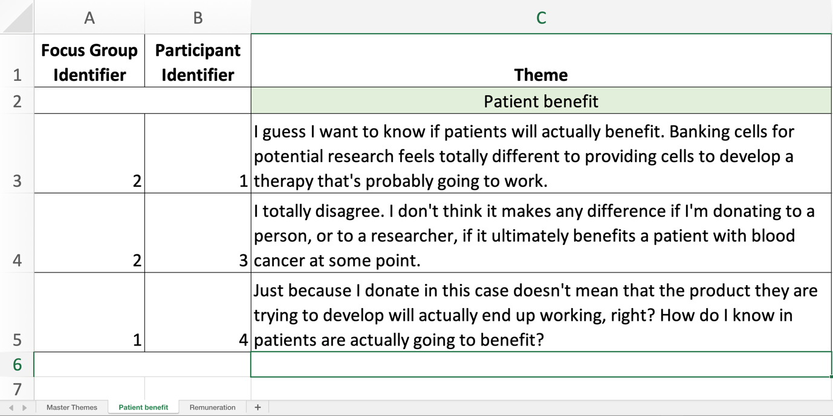

The idea here is to collect all of the relevant speech that relates to different themes, so you can zoom in on the specific theme and consider the responses. Is there general agreement, or lots of diversity of opinions? Either way, this tells you something interesting.

Then you can collate all the themes into one larger document, that can help you to structure your findings or report after analysis. Below is an example, though yours is likely to have multiple themes and many excerpts of speech from your discussion groups.

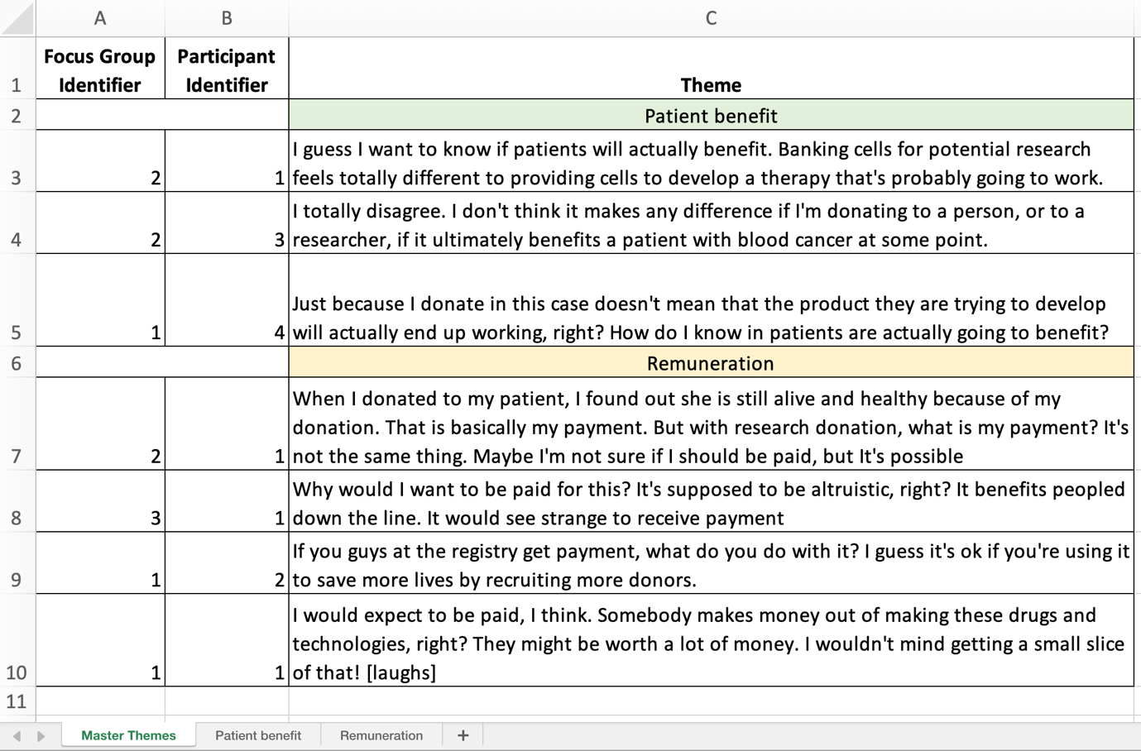

Summarise your findings into a report.

As with any report, first describe your sample by using participants’ demographics collected for your discussion groups.

Your report will then provide some analysis of the themes you consider important and that help provide insight into your participants’ views. For example, you might have a section where you discuss the theme of donor remuneration. Maybe most of your participants agreed that they wouldn’t wish to be remunerated for donations to cell and gene therapy research, or perhaps some participants were less sure of this. Perhaps somebody was certain they wanted to be. Maybe somebody else wanted to know more about what would happen if the registry received a fee. Provide a quote that encapsulates each position. Then reflect on what this means for your organisation – this might mean building on prior knowledge and the current position of your organisation or regulator (e.g., you may have done research previously about remuneration, or there may be local legislation or regulation on this issue).

Because this report is for your organisation, each theme might then generate a recommendation or two. For example, the above theme on remuneration might generate a recommendation that future research via a survey should ask specifically about donors’ views on the registry receiving a fee for its cell and gene therapy work – is this acceptable or not to your donor base? Another recommendation might be that you organise a local organisational discussion on what use those fees might be put to – developing the registry? Expanding your cell and gene therapy operations? It might also lead to a recommendation that you speak to your regulatory body about remuneration for donors, and what the rules for this might be, as they could be different from donation for transplantation.

Your executive summary and conclusion should summarise the main themes and recommendations.

Informed Consent and Local Ethical Review

Consider what kinds of local approval you will need before undertaking the research.

This resource kit has been designed so you can run a small-scale piece of local research within your registry. It may or may not be appropriate to seek approval from decision-makers in your organisation. National or regional rules may mean you must seek IRB approvals to undertake the research, though you may not need to do this. Seek advice from colleagues on this matter if you are unsure.

Included in this resource kit is a document with Resources for Institutional Review Applications. It includes relevant components of a completed ethical review application which was approved by The University of Sheffield University Research Ethics Committee in November 2021. You may wish to use this text as the basis of your own application, should you require it. It considers participant and researcher well-being, and explains how data will be treated.

Seek informed consent from your discussion group participants.

Regardless of whether you are required to undertake local review, it is good practice to seek informed consent from your participants to undertake discussion groups. This is for various reasons: so your participants know what they are (and are not) agreeing to; so your participants are aware of the themes of the research; to maintain good relationships with your donors for the future. It is also a useful way of capturing basic demographic information about your sample that can help with your analysis and generation of results.

This resource kit includes a template consent form (Example Participant Information and Consent Form) for you to adapt for this purpose.

