Peer Review & Consultation questionnaire

Reviewed Transplant community organization:
Ossium Health
8941

Reviewing Transplant community organization:
Klik of tik om tekst in te voeren.
Klik of tik om tekst in te voeren.

The reviewed transplant community organization (TCO) holds the following accreditations:
☐ WMDA accreditation
☐ ISO 27001 or comparable local standard
☐ ISO 27018 or comparable local standard

# | Subject | compliance | Comments | GDPR | AU Privacy Act | US DPR
1 | Subject Consent (applicable to data controllers only) |  |  | II
1.1.  1.2. | Is the TCO acting as a data processor only for donor data?  If so: continue with question 2.1.  Does the TCO have adequate procedures in place to ask, store and retrieve consent from donors from who it collects personal information and for who it acts in the capacity of data controller? | ☒  ☐ | Klik of tik om tekst in te voeren. | II.7 |  | §164.502
1.3. | In case the TCO acts as a co-controller for the collection of patient data: does it have adequate procedures in place to ask, store and retrieve consent from patients or the assurance that the transplant center obtains, stores and retrieves such consent? | ☐ | Klik of tik om tekst in te voeren. | II.7 | APP 11 | §164.502
1.4. | Does the donor’s consent encompass portability to other TCO’s and WMDA to allow matching with patients? | ☐ | Klik of tik om tekst in te voeren. | III.20 | APP 8 | §164.502
1.5. | Is all collected information sufficiently specified and explained in the TCO’s consent forms? | ☐ | Klik of tik om tekst in te voeren. | II.9 | APP 1 | §164.502
1.6. | Does the TCO’s state law allow exemption for medical and/or other sensitive data collected? | ☐ | Klik of tik om tekst in te voeren. | II.9.2a | APP 8 | §164.502
2 | Information and access to personal data |  |  | III.S2
2.1. | Does the TCO have procedures in place -either in its capacity of data controller or as data processor documented data use agreements- to confirm the collection of personal data at the time when personal data are obtained and does such confirmation include:  - contact details of the TCO  - the purpose of the processing for which the personal data are intended and other details provided in the donor or patient’s consent or a reference to that consent  - details about the period for which the data are stored  - the right to access or erase personal data  - the right to lodge a complaint with a supervisory authority | ☐  ☐  ☐  ☐  ☐ | Not applicable. Ossium Health does not collect personal data from donors. Ossium Health receives deceased donor data from Organ Procurement Organizations. | III.13.1 | APP 10
2.2. | Does the TCO have procedures in place to provide access to personal data to donors within one month after receipt of a request thereto from the donor or the data controller of donor data? | ☐ | Not applicable. Ossium Health’s donors are deceased and cannot request access to their personal data. | III.15 | APP 12 | 45 CFR 164.524
3 | Rectification and erasure of personal data |  |  | III.S3
3.1. | Does the TCO have procedures in place for donors or the data controllers of donor data to rectify personal information, either by direct access or a request? | ☐ | Not applicable. Ossium Health’s donors are deceased and cannot request to rectify personal information. | III.16 | APP 13 | NA
3.2. | Does the TCO have procedures in place to erase personal data or anonymize donor records in such way that the donor can no longer be identified at the request of the donor or the data controller of donor data? | ☐ | Not applicable. Ossium Health’s donors are deceased and cannot request for their data to be erased. | III.17 | APP 1 | NA
3.3. | Is the TCO acting as a data processor only for donor data?  If so: continue with question 4.1. | ☒ | Klik of tik om tekst in te voeren.
3.4. | In case the TCO acts as data controller: does the TCO have procedures in place to erase personal data or anonymize donor records in such way that the donor can no longer be identified when the donor no longer fulfills the criteria for being registered? | ☐ | Klik of tik om tekst in te voeren. | III.18 | APP 1 | NA
3.5. | In case of the action described under 3.3.: does the donor receive notification of the erasure? | ☐ | Klik of tik om tekst in te voeren. | III.19 | APP 10 | NA
4 | Data processing responsibilities |  |  | IV.S1
4.1. | Does the TCO have data processing agreements or co-controlling arrangements in place with other TCO’s to whom personal or pseudonymized data is provided? | ☒ | Klik of tik om tekst in te voeren. | IV.24  IV.26  IV.28 | APP 8 | §164.502  (e)(1)(ii)
4.2. | Does the TCO comply with requirements for controllers or processors outside the European Union? | ☒ | Klik of tik om tekst in te voeren. | IV.27 | APP 8
5 | Data security and data breach provisions |  |  | IV.S2
5.1. | Does the TCO have a written information security policy in place? | ☒ | Klik of tik om tekst in te voeren.
5.2. | Does the TCO have adequate security measures in place to protect personal data, to include but not limited to: e.g.  - Regular penetration testing and a record of remedial action based on the findings of such testing | ☒ | Klik of tik om tekst in te voeren. | IV.32 | APP 11 | §164.308  §164.310  §164.312
5.3. | Is a procedure in place to notify the supervisory authority or the data controller in case of a personal data breach within the limits as the regulations or the data processing agreements require? | ☒ | Klik of tik om tekst in te voeren. | IV.33 | APP 11 | § 164.410  (a)(1)
5.4. | Is a procedure in place to notify the donor or the data controller in case of a personal data breach within the limits as the regulations or the data processing agreements require? | ☒ | Klik of tik om tekst in te voeren. | IV.34 | APP 11 | § 164.410  414
5.5. | Does the TCO have examples of such notifications and can it demonstrate compliance with the regulations in these cases? | ☐ | Not applicable. Ossium Health has not experienced a personal data breach. | IV.33  IV.34 | APP 11
6 | Data protection impact assessment |  |  | IV.S3
6.1. | Does the TCO have procedures in place to assess and classify security risks, including but not limited to:  - Environmental incidents, acts of God  - Hardware failure  - Physical access to data | ☒  ☒  ☒ | Klik of tik om tekst in te voeren. | IV.35 | APP 11 | §164.308  (a)(1)(ii)(A)
6.2. | Does the TCO have adequate backup procedures?  for example:  - data mirroring to prevent interruption of operations in case of hardware failure  - complete recovery of the systems environment for a limited period  - procedures to restore data and testing thereof  - interval backup’s | ☒ | Klik of tik om tekst in te voeren. | IV.35 | APP 11 | §164.308  (a)(7)(ii)(A)
7 | Data Protection Officer |  |  | IV.S4
7.1. | Did the TCO appoint a Data Protection Officer in compliance with local regulations? | ☒ | Klik of tik om tekst in te voeren. | IV.37 | APP 1 | 45 CFR  164.308

Reviewer comments
1 | Did the reviewer verify the above checklist and did the TCO provide reasonable evidence to demonstrate compliance in so far it claimed such compliance? | ☐ | Klik of tik om tekst in te voeren.
2 | Did the reviewer recommend any improvements and did the TCO commit to implement such improvements? | ☐ | Klik of tik om tekst in te voeren.

The transplant community organization and the reviewer hereby declare that this compliance statement is truthful and unconditional
Date:24-Jul-24 | Date:Klik of tik om een datum in te voeren.
TCO: | Reviewer:
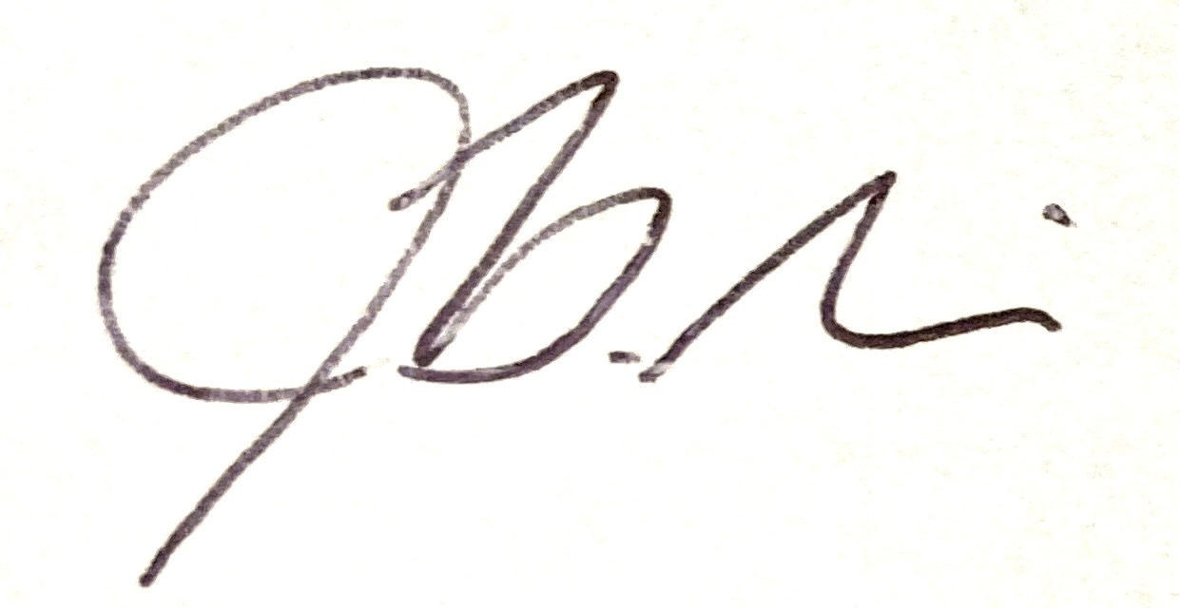 | 
Name: Jane Griffin | Name:Klik of tik om tekst in te voeren.

